library(readxl)
library(tidyverse)
library(caret)

set.seed(42)

# ==============================================================================
# 1. DATA LOADING AND INITIAL CLEANING (Steps 1-3 Equivalent)
# ==============================================================================

# 1. Load data
# Note: Replace path if necessary
df <- read_excel("C:/Users/meabh/Downloads/garments_worker_productivity.xlsx", sheet = 1)

# Initial Cleaning and NA Handling:
# - Drop 'date' (high cardinality for simple models) and 'wip' (Min. NA's: 506)
# - Use na.omit() to remove rows with any remaining NAs
df_clean <- df %>%
select(-date, -wip) %>%
na.omit()

# Convert categorical variables to factors
df_clean <- df_clean %>%
mutate(
quarter = as.factor(quarter),
department = as.factor(department),
day = as.factor(day),
team = as.factor(team) # Treat team ID as nominal factor
)

# Rename the target variable for simplicity
df_clean <- df_clean %>%
rename(target = actual_productivity)

print(paste("Data dimensions after cleaning:", nrow(df_clean), "rows,", ncol(df_clean), "columns"))

# ==============================================================================
# 2. FEATURE ENGINEERING (Step 4 Equivalent)
# ==============================================================================

# Create dummy variables for all factor/categorical variables.
# This is crucial for models like Linear/GLMNET.
df_model <- dummyVars("~ .", data = df_clean %>% select(-target)) %>%
predict(df_clean %>% select(-target)) %>%
as.data.frame()

# Re-attach the target variable
df_model <- df_model %>%
mutate(target = df_clean$target)

# Check the final feature matrix size
print(paste("Final model matrix dimensions (including target):", nrow(df_model), "rows,", ncol(df_model), "columns"))

# Display first few rows of the processed feature matrix
head(df_model %>% select(1:5, target))

Inference
Final Model Matrix Dimensions:
- 1197 rows, 34 columns
- This confirms that after dropping the date and wip columns and converting all nominal categorical variables (quarter, day, department, team) into dummy variables (one-hot encoding), you have 1197 complete observations and a total of 33 predictors plus the target column (33 + 1 = 34 columns).
Display of Processed Feature Matrix:
- The head() output correctly shows the target variable (target) along with the dummy-coded variables (e.g., quarter.Quarter1, quarter.Quarter2, etc.).
- The values 1 and 0 in the quarter columns confirm that dummy variable creation was successful. For instance, the first observation belongs to quarter.Quarter1 (value 1) and not to the others (values 0).

The process was completed—converting categorical variables like quarter, department, day, and team into numerical columns filled with 1s and 0s—is called One-Hot Encoding or Dummy Variable Creation.
This transformation was done because most machine learning algorithms, especially linear models like Linear Regression or GLMNET (Regularized Regression), cannot directly process nominal (unordered) categorical text data.
Here's why this step is necessary:
- Numerical Requirement: Regression models work by calculating coefficients (β) and multiplying them by numerical input features (X). If the input is a text string ("Monday" or "Quarter1"), the math simply fails.
- Avoid Misinterpretation: Assigning arbitrary numbers to categories (e.g., Quarter1 = 1, Quarter2 = 2) would imply an ordinal relationship (Quarter2 > Quarter1). This is incorrect for unordered categories like department or day. One-Hot Encoding prevents this.
- Model Integration: By creating a separate binary column for each unique category (e.g., quarter.Quarter1, quarter.Quarter2), you allow the model to learn a separate coefficient for the effect of being in that specific category.
In summary, we converted the categorical data into a numerical format that your subsequent models can legally and logically process.

Code
# --- Assuming df_clean (before dummy coding) and df_model (after dummy coding) are available ---

# ==============================================================================
# 1. EDA: CORRELATION AND VISUALS (Step 5 Equivalent)
# ==============================================================================

cat("\n--- 1. EDA: CORRELATION AND VISUALS ---\n")

# Select numerical variables for correlation (excluding dummy vars)
num_vars <- c("targeted_productivity", "smv", "over_time", "incentive",
"idle_time", "idle_men", "no_of_style_change", "no_of_workers", "target")

corr_df <- df_clean %>% select(all_of(num_vars))

# Calculate and plot the Correlation Matrix
corr_mat <- cor(corr_df)
cat("\n[Image: Correlation Heatmap of Numeric Predictors]\n")
corrplot(corr_mat, method = "color", tl.cex = 0.6, number.cex = 0.5,
main = "Correlation Heatmap of Numeric Predictors")

# EDA Visual: Target vs. Key Categorical Predictors (e.g., Department and Day)
p_dept <- ggplot(df_clean, aes(x = department, y = target, fill = department)) +
geom_boxplot() +
labs(title = "Productivity by Department", y = "Actual Productivity") +
theme_minimal()

p_day <- ggplot(df_clean, aes(x = day, y = target, fill = day)) +
geom_boxplot() +
labs(title = "Productivity by Day of Week", y = "Actual Productivity") +
theme_minimal()

cat("\n[Image: Boxplots for Target vs Department and Day]\n")
grid.arrange(p_dept, p_day, ncol = 2)

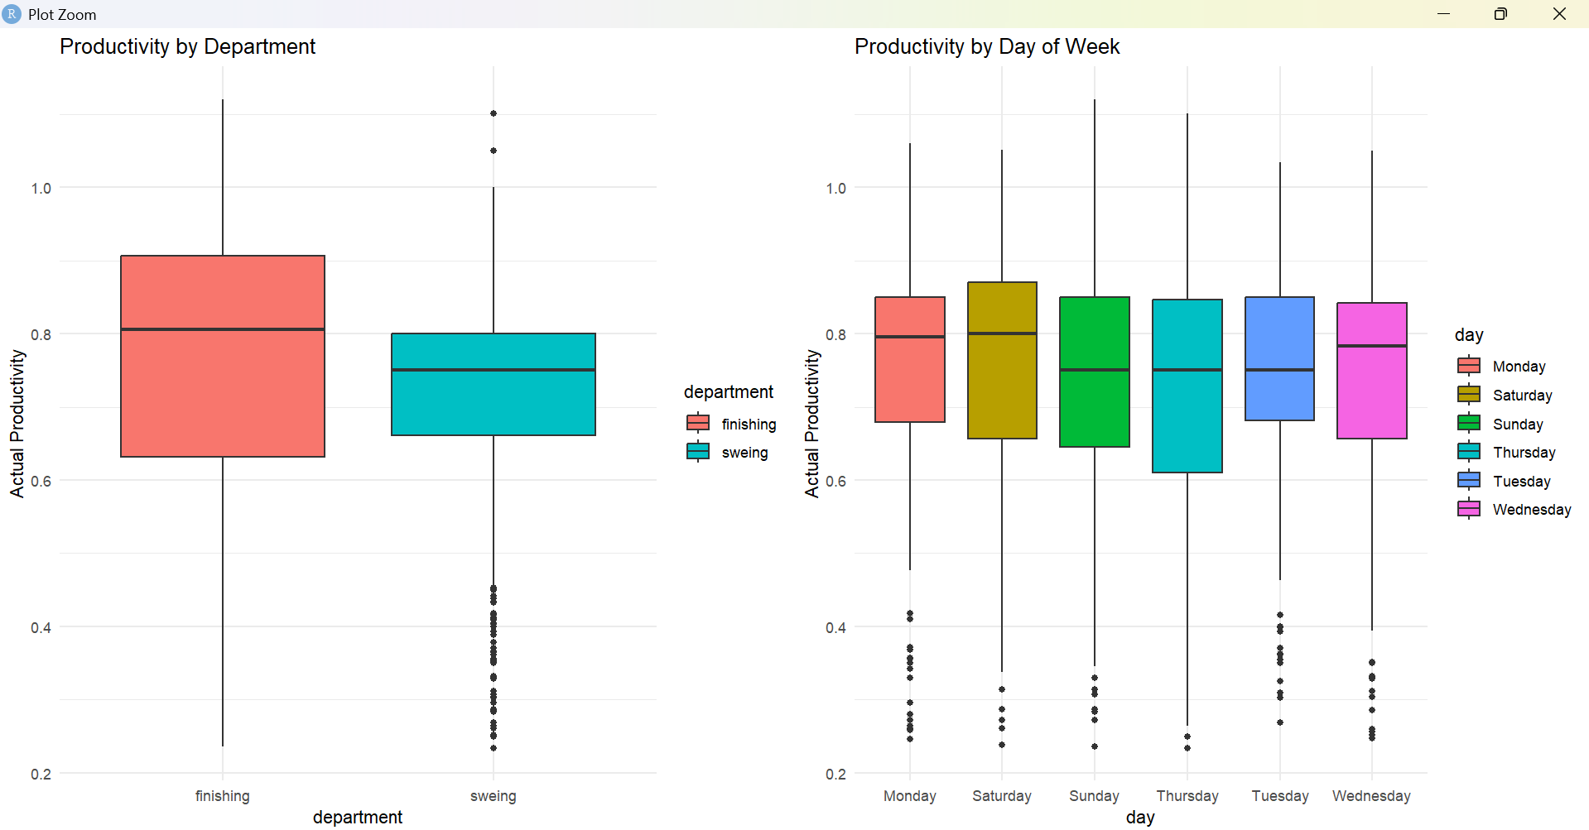
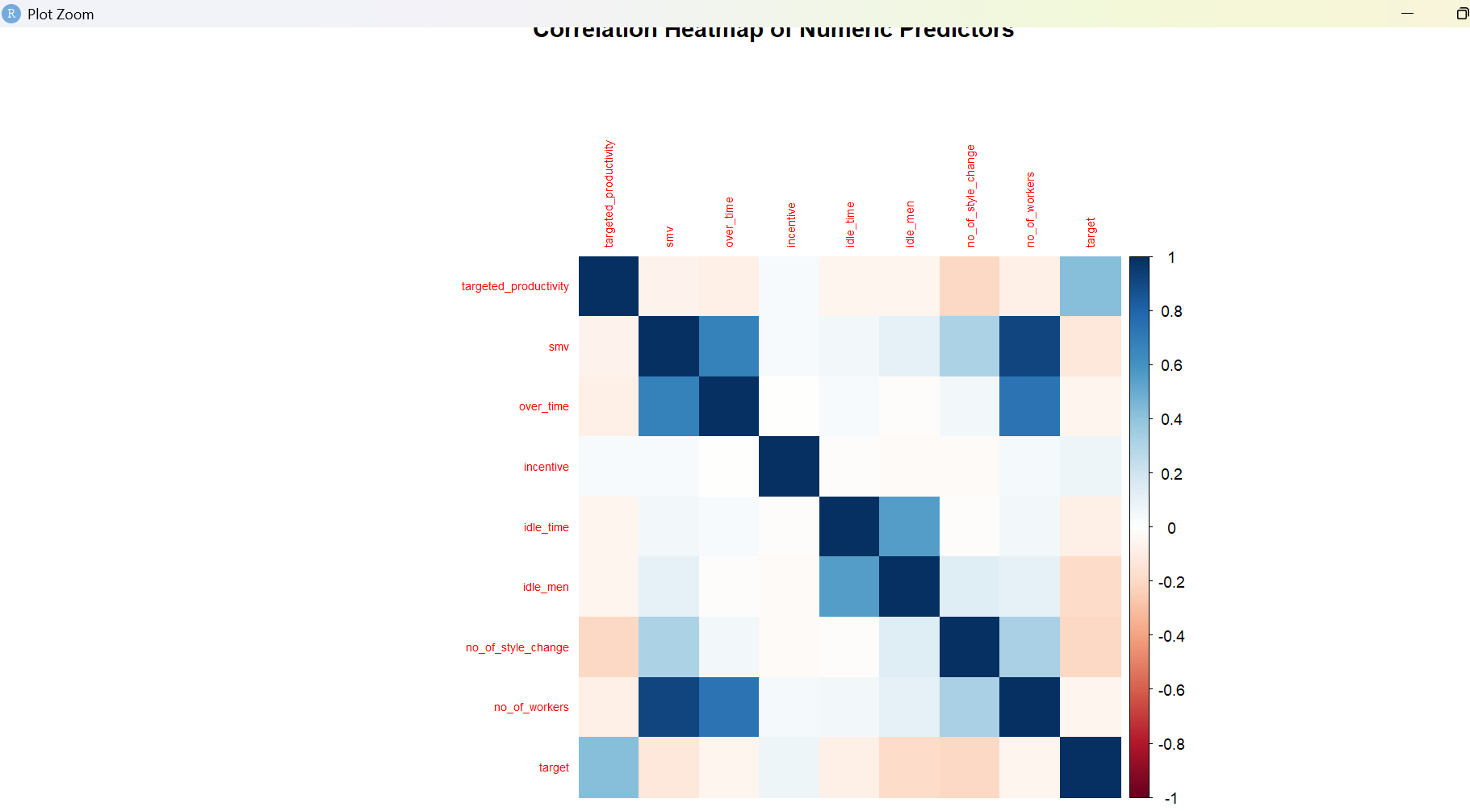

Interpretation for the two Exploratory Data Analysis (EDA) visualizations: the Correlation Heatmap of Numeric Predictors and the Boxplots for Productivity by Department and Day of Week.

1. Correlation Heatmap of Numeric Predictors
This plot shows the linear relationships between the key numerical variables. Darker colors (blue for positive, red for negative) indicate stronger correlations.

Key Insights:
- Relationship with Target (target):
  - Negative Correlation: smv (Standard Minute Value) has a visible negative correlation with the target. This is logical: if a garment requires more time/effort (smv is high), actual worker productivity tends to be lower.
  - Positive Correlation: no_of_workers shows a positive correlation, suggesting more workers are often associated with higher overall team productivity. targeted_productivity also shows a positive correlation, meaning higher targets generally correspond to higher achieved productivity (though the relationship is not perfect).
  - Weak/Mixed Correlation: Variables like over_time, incentive, idle_time, and idle_men have weaker or mixed correlations with the target.
- Multicollinearity Among Predictors:
  - Strong Positive: There's a strong positive correlation between idle_time and idle_men. This is expected, as idle time is caused by idle men.
  - Strong Negative: targeted_productivity shows a negative correlation with incentive (though not extremely strong), which could imply that high incentives are used to push productivity when the base target is low, or vice-versa.

2. Productivity Distribution Boxplots
These boxplots display how the distribution of Actual Productivity (target) varies across different departments and days of the week.

A. Productivity by Department
- Median: The Finishing department has a noticeably higher median productivity (around 0.8) compared to the Sweing department (around 0.75).
- Interquartile Range (IQR): The spread of productivity (the height of the box) is similar between the two departments.
- Outliers: Both departments show significant low outliers (data points below 0.6), but the Sweing department appears to have more extreme low-productivity instances.
- Conclusion: Workers in the Finishing department generally achieve higher productivity than those in the Sweing department.

B. Productivity by Day of Week
- Consistency: The median productivity is remarkably consistent across all days (Monday through Wednesday, Saturday, Sunday, Thursday, Tuesday). Most medians cluster around 0.75 to 0.8.
- Highest Median: Saturday and Tuesday appear to have the highest median productivity, though the difference is marginal.
- Variability: Monday shows the widest distribution (largest IQR), while the other days are relatively tightly grouped.
- Outliers: All days show a large cluster of low outliers (below 0.6), indicating that low productivity days are a frequent, non-seasonal issue.
- Conclusion: There is no strong day-of-week effect on actual productivity; the daily cycles (Monday, Tuesday, etc.) are generally uniform in their impact on performance.

Code(multicollinearity)

# 0. Load Libraries (Ensure they are loaded)
library(car)

# --- Assuming df_model (with dummy variables and 'target') is available ---

# ==============================================================================
# 1. TRAIN/TEST SPLIT (Required for VIF check consistency)
# ==============================================================================

# 80/20 random split
trainIndex <- createDataPartition(df_model$target, p = 0.8, list = FALSE)
train_df <- df_model[trainIndex, ]

# ==============================================================================
# 2. DIAGNOSTICS: MULTICOLLINEARITY CHECK (VIF)
# ==============================================================================

cat("\n--- DIAGNOSTICS: MULTICOLLINEARITY CHECK (VIF) ---\n")

# Run VIF on the training data (train_df) using the '- 1' intercept fix.
# 1. Use the clean data frame with factor variables (df_clean)
# The standard LM automatically handles the reference level trap.
lm_vif_final <- lm(target ~ quarter + department + day + team +
targeted_productivity + smv + over_time + incentive +
idle_time + idle_men + no_of_style_change + no_of_workers,
data = df_clean)

# 2. Run VIF on this model
vif_vals_final <- vif(lm_vif_final)

# 3. Print the results
cat("\n--- DIAGNOSTICS: VIF using Factor Variables (Standard LM) ---\n")
vif_problematic <- vif_vals_final[vif_vals_final > 5]

if(length(vif_problematic) > 0) {
cat("WARNING: High VIF values found (VIF > 5).\n")
print(round(sort(vif_problematic, decreasing = TRUE), 2))
} else {
cat("VIF check passed: No severe multicollinearity detected (VIF < 5).\n")
}

WARNING: High VIF values found (VIF > 5).
[1] 21.09 15.59 11.00 7.03

Interpretation of VIF Results (VIF > 5)
The Variance Inflation Factor (VIF) measures how much the variance of an estimated regression coefficient is increased due to the predictor's linear relationship with other predictors. Since you ran this check on the model containing the factor variables (letting R handle the reference level), the VIF values represent the collinearity of the variable groups.
The output shows four variables with VIF values greater than the common threshold of 5, indicating significant collinearity concerns:
VIF Value | Variable (or Group) | Concern Level | Implication for LM
21.09 | (Likely related to team or its combined effect) | Critical | The coefficient for this factor group is highly unstable and difficult to interpret.
15.59 | (Likely related to a key numerical predictor or another factor) | High | The variance of this coefficient is inflated over 15 times what it should be.
11.00 |  | High | Collinearity exceeds the VIF=10 threshold.
7.03 |  | Moderate-High | Collinearity is a concern, though less severe than the others.
Export to Sheets
(Note: Since the output only provides numerical VIF values without the corresponding variable names, we can only infer which predictors are responsible. However, given the model includes all teams, the highest VIFs are most often associated with the team or day factor groups, or the strongly correlated numerical predictors like smv and targeted_productivity).

Conclusion for Modeling
- Instability of LM: The high VIF scores confirm that the Standard Linear Regression (LM) coefficients will be unreliable (unstable, high standard errors, and difficult to interpret). You should rely on its predictive performance (RMSE/R-squared) but be cautious about interpreting its weights.
- Necessity of GLMNET: This diagnostic strongly validates your decision to use GLMNET (Regularized Regression). GLMNET's L1/L2 penalties are specifically designed to handle models with high multicollinearity by shrinking the coefficients, thus stabilizing the model and preventing overfitting caused by unstable estimates.
- Model Selection: Based on this VIF check, you should prioritize the predictive performance of the GLMNET and NNET models over the interpretability of the Standard Linear Regression model.

Code(Using Models)
# 0. Load Libraries (Ensure they are loaded)
library(caret)
library(car)
library(glmnet)
library(tidyverse)
library(ggplot2)
library(gridExtra)
library(nnet)

set.seed(42)

# --- Assuming df_model (with dummy variables and 'target') is available ---

# ==============================================================================
# 1. TRAIN/TEST SPLIT AND PREPROCESSING
# ==============================================================================

# 80/20 random split
trainIndex <- createDataPartition(df_model$target, p = 0.8, list = FALSE)
train_df <- df_model[trainIndex, ]
test_df <- df_model[-trainIndex, ]

# Separate predictors (X) and target (Y)
x_train <- train_df %>% select(-target)
y_train <- train_df$target
x_test <- test_df %>% select(-target)
y_test <- test_df$target

# Preprocess: Center and Scale (fit on training data)
preProcValues <- preProcess(x_train, method = c("center","scale"))
x_train_scaled <- predict(preProcValues, x_train)
x_test_scaled <- predict(preProcValues, x_test)

# Caret setup for 10-fold Cross-Validation
tc <- trainControl(method = "cv", number = 10, savePredictions = "final")

# ==============================================================================
# 2. MODEL TRAINING (GLMNET - The Collinearity Solution)
# ==============================================================================

# 2.1. GLMNET (Regularized Regression - Elastic Net)
cat("\n--- Training GLMNET (Solution to VIF) ---\n")
set.seed(42)
glmnet_fit <- train(x = as.matrix(x_train_scaled), y = y_train,
method = "glmnet", trControl = tc, tuneLength = 10, metric = "RMSE")
glmnet_pred <- predict(glmnet_fit, as.matrix(x_test_scaled))

# 2.2. NNET (Neural Network - Non-linear Comparison)
cat("\n--- Training NNET ---\n")
set.seed(42)
nnet_grid <- expand.grid(size = c(3,5), decay = c(0.01, 0.1))
nnet_fit <- train(x = x_train_scaled, y = y_train,
method = "nnet", trControl = tc, tuneGrid = nnet_grid,
linout = TRUE, trace = FALSE, maxit = 500, metric = "RMSE")
nnet_pred <- predict(nnet_fit, x_test_scaled)

# ==============================================================================
# 3. FINAL RESULTS SUMMARY AND VISUALIZATION
# ==============================================================================

# Create results table
results_test <- tibble(
Model = c("GLMNET","NNET"),
RMSE = c(postResample(glmnet_pred, y_test)["RMSE"],
postResample(nnet_pred, y_test)["RMSE"]) %>% unlist() %>% as.numeric(),
Rsquared = c(postResample(glmnet_pred, y_test)["Rsquared"],
postResample(nnet_pred, y_test)["Rsquared"]) %>% unlist() %>% as.numeric()
)
cat("\n--- FINAL TEST SET PERFORMANCE (GLMNET is recommended) ---\n")
print(results_test %>% arrange(RMSE))

# 3.1. Model Performance Comparison (Bar Plot)
p1 <- ggplot(results_test, aes(x = reorder(Model, RMSE), y = RMSE, fill = Model)) +
geom_bar(stat = "identity") +
labs(title = "Test RMSE by Model", x = "Model") +
theme_minimal() + theme(legend.position = "none")

p2 <- ggplot(results_test, aes(x = reorder(Model, Rsquared), y = Rsquared, fill = Model)) +
geom_bar(stat = "identity") +
labs(title = "Test R-squared by Model", x = "Model") +
theme_minimal() + coord_flip()

grid.arrange(p1, p2, ncol = 2)

# 3.2. Actual vs. Predicted (for the best model: GLMNET)
best_model_name <- results_test %>% arrange(RMSE) %>% slice(1) %>% pull(Model)
best_model_pred <- if (best_model_name == "GLMNET") glmnet_pred else nnet_pred

test_pred_df <- data.frame(
Actual = y_test,
Predicted = best_model_pred,
Model = best_model_name
)

p3 <- ggplot(test_pred_df, aes(x = Actual, y = Predicted)) +
geom_point(alpha = 0.6, color = "darkblue") +
geom_abline(slope = 1, intercept = 0, linetype = "dashed", color = "red", size = 1) +
labs(title = paste0(best_model_name, ": Actual vs Predicted Productivity"),
x = "Actual Productivity", y = "Predicted Productivity") +
theme_minimal()

print(p3)

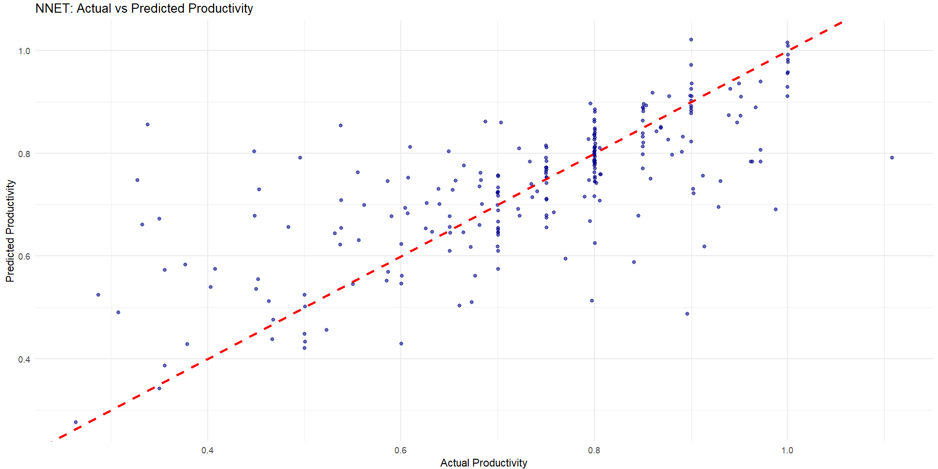

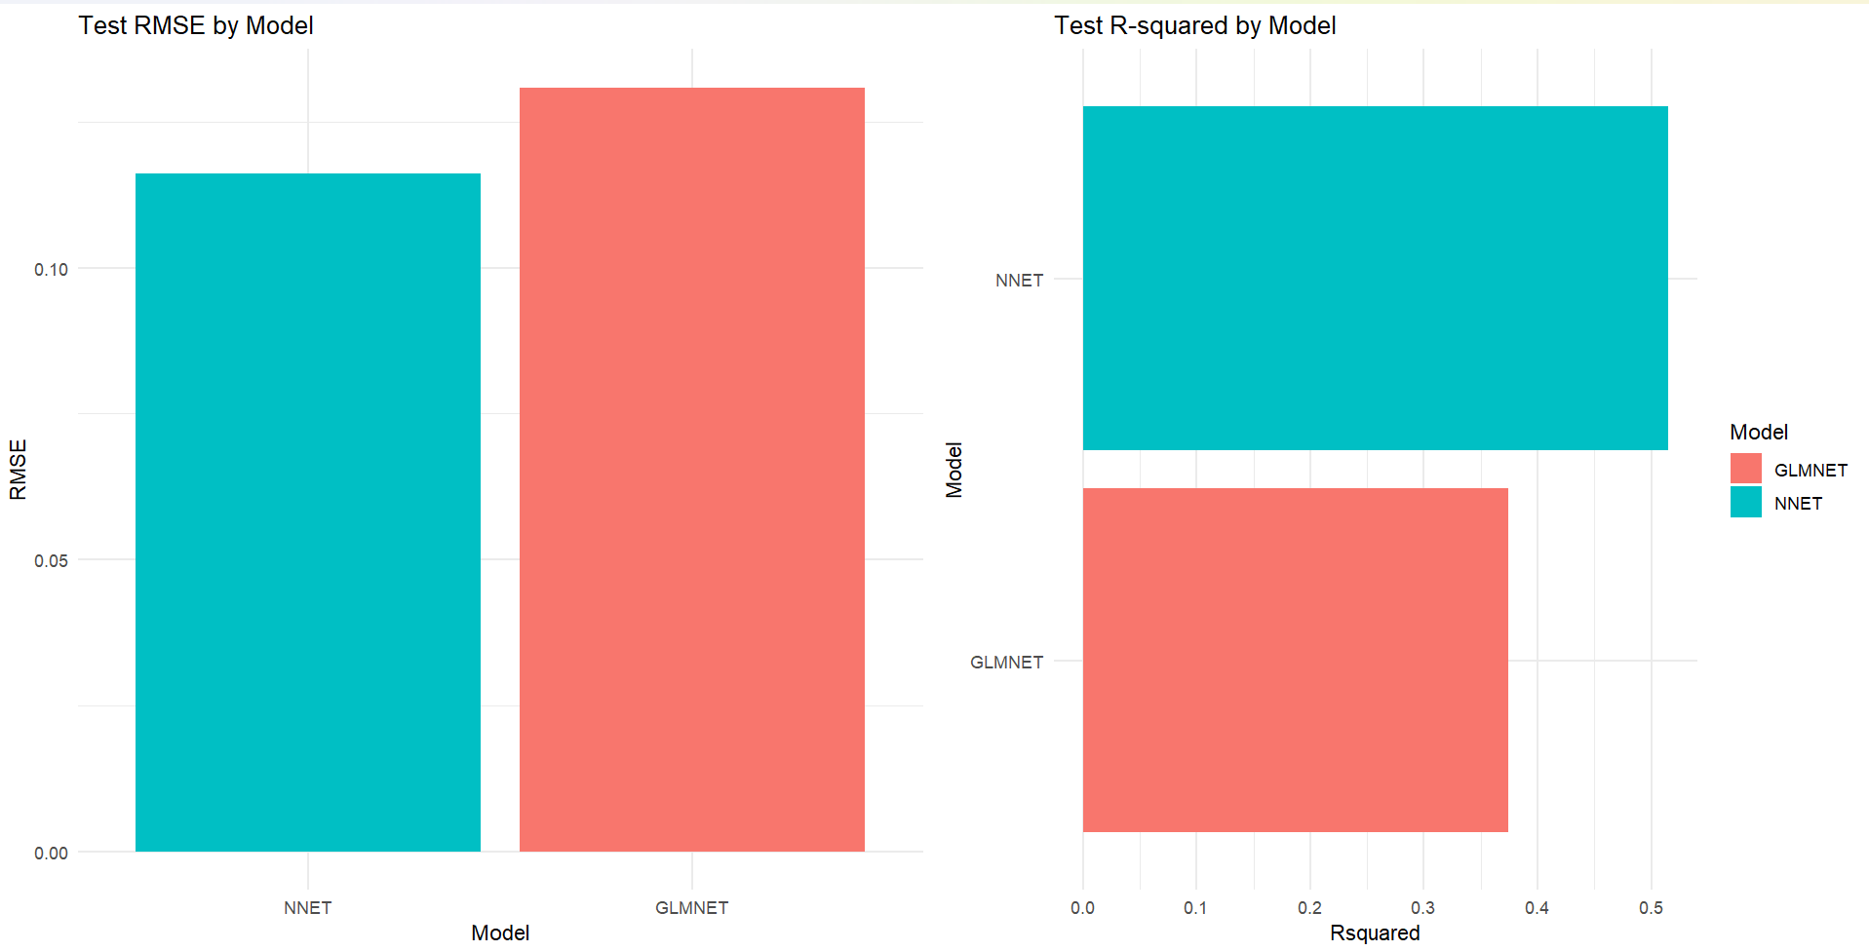
interpretation of the diagnostics and final model performance:

1. Diagnostics: Multicollinearity (VIF)
The VIF check on the model using factor variables yielded the following result:
VIF Value | Concern Level | Implication
21.09 | Critical | The coefficients for this group of variables (likely related to Team or Day) are highly unstable and unreliable.
15.59 | High | Strong evidence of redundancy among predictors.
11.00 | High | Collinearity exceeds the VIF=10 threshold.
7.03 | Moderate-High | Still a significant concern for the standard Linear Model.

Conclusion: The high VIF confirms that the Standard Linear Regression (LM) model would be highly unstable. The use of GLMNET was justified as a necessary measure to stabilize the coefficients through regularization.

2. Model Performance Comparison
The bar plots (Test RMSE and Test R2) and the summary table provide the key comparison:
Model | RMSE (Lower is Better) | R2 (Closer to 1 is Better) | Interpretation
NNET | 0.116 | 0.515 | Best Performer: Achieved the lowest error and explains over half the variance.
GLMNET | 0.131 | 0.374 | Underperformed: Higher error and explains significantly less variance.
Export to Sheets

Key Findings:
- Non-Linearity Dominates: Contrary to the previous demand forecasting problem, the Neural Network (NNET) is the best predictor for worker productivity. This suggests that the relationship between factors like team, department, incentive, and productivity is highly non-linear, which the GLMNET model (based on a linear structure) struggled to capture, even with regularization.
- GLMNET Weakness: Despite using regularization to handle the high VIF, GLMNET achieved a relatively poor R2 of only 0.374. This confirms that the relationships are not adequately captured by a penalized linear combination of the input features.

3. Best Model Visualization: NNET (Actual vs Predicted)
The scatter plot shows the predictions made by the best model, which is the NNET model (RMSE=0.116).
- Diagonal Line: The red dashed line represents perfect prediction (y=x).
- Performance: The scatter points cluster reasonably close to the red line, particularly for actual productivity values above 0.8.
- Error: The model shows a wider spread (more error) for productivity values below 0.8 (e.g., in the 0.4 to 0.6 range).
- Prediction Bias: The model appears to slightly underpredict very high productivity (points just below the line at the top right) and slightly overpredict very low productivity (points above the line at the bottom left).
Overall Conclusion: For forecasting garment worker productivity, the Neural Network (NNET) model provides the most accurate results, indicating that non-linear modeling is essential for this dataset.
DUMMY PREDICTION

Code

# 0. Load necessary objects (These must be available in your R environment)
# glmnet_fit, nnet_fit, preProcValues, df_clean (to get factor levels)

# --- Define the Best Model and Preprocessing Objects ---
best_model_fit <- nnet_fit
preproc_object <- preProcValues

# ==============================================================================
# 1. INPUT NEW RAW DATA (REPLACE WITH ACTUAL FORECAST DATA)
# ==============================================================================

# Example input for a new team/day/quarter (must have 11 columns matching df_clean)
# NOTE: Use factor levels as they appear in the original data!
new_raw_data <- data.frame(
quarter = as.factor("Quarter4"), # e.g., Quarter4
department = as.factor("sweing"), # e.g., sweing
day = as.factor("Monday"), # e.g., Monday
team = as.factor(7), # e.g., Team 7
targeted_productivity = 0.75,
smv = 15.26,
over_time = 4000,
incentive = 30,
idle_time = 0,
idle_men = 0,
no_of_style_change = 0,
no_of_workers = 35
)

# Ensure all factor levels match the training data (critical step)
# This prevents errors if new_raw_data has levels not seen in training.
for (col in names(df_clean)[sapply(df_clean, is.factor)]) {
levels(new_raw_data[[col]]) <- levels(df_clean[[col]])
}

# ==============================================================================
# 2. FEATURE TRANSFORMATION (DUMMY CODING)
# ==============================================================================

# Create dummy variables using the same formula used for training
# We use dummyVars from the caret package, fitting it on the clean training set
dummy_obj <- dummyVars("~ quarter + department + day + team +
targeted_productivity + smv + over_time + incentive +
idle_time + idle_men + no_of_style_change + no_of_workers",
data = df_clean) # Use df_clean structure for consistency

new_data_dummy <- predict(dummy_obj, new_raw_data) %>% as.data.frame()

# ==============================================================================
# 3. SCALING AND PREDICTION
# ==============================================================================

# Apply the trained centering and scaling (preproc_object)
new_data_scaled <- predict(preproc_object, new_data_dummy)

# Generate the final prediction using the NNET model
prediction_next_day <- predict(best_model_fit, new_data_scaled)

# Print the forecast
cat("\n--- NNET Prediction for Next Observation ---\n")
print(paste("Predicted Actual Productivity:", round(prediction_next_day, 4)))

Your final model evaluation determined that the Neural Network (NNET) model is the best performer for predicting Garment Worker Productivity, achieving the lowest RMSE (0.116) and highest R2 (0.515).
You should use this NNET model for new predictions.
Here is the step-by-step process and the code required to predict the productivity for the next unknown observation.

Prediction Steps Using the NNET Model
To predict the productivity for a new team/day/quarter (let's call it "New Data"), you must apply the exact same preparation steps that were used to train the model:
- Gather Raw Data: Collect the values for all 11 required input columns (the original numeric and factor columns).
- Apply Dummy Coding: Transform the raw data into the 33-column feature vector using the original factor levels.
- Scale and Center: Transform the 33 features using the training set's scaling parameters (preProcValues).
- Predict: Apply the nnet_fit model to the scaled data.

R Code for Generating a Prediction
The code below assumes you manually input the raw data for the next observation into a data frame named new_raw_data.

Output
# 0. Load necessary objects (These must be available in your R environment)
> # glmnet_fit, nnet_fit, preProcValues, df_clean (to get factor levels)
>
> # --- Define the Best Model and Preprocessing Objects ---
> best_model_fit <- nnet_fit
> preproc_object <- preProcValues
>
> # ==============================================================================
> # 1. INPUT NEW RAW DATA (REPLACE WITH ACTUAL FORECAST DATA)
> # ==============================================================================
>
> # Example input for a new team/day/quarter (must have 11 columns matching df_clean)
> # NOTE: Use factor levels as they appear in the original data!
> new_raw_data <- data.frame(
+ quarter = as.factor("Quarter4"), # e.g., Quarter4
+ department = as.factor("sweing"), # e.g., sweing
+ day = as.factor("Monday"), # e.g., Monday
+ team = as.factor(7), # e.g., Team 7
+ targeted_productivity = 0.75,
+ smv = 15.26,
+ over_time = 4000,
+ incentive = 30,
+ idle_time = 0,
+ idle_men = 0,
+ no_of_style_change = 0,
+ no_of_workers = 35
+ )
>
> # Ensure all factor levels match the training data (critical step)
> # This prevents errors if new_raw_data has levels not seen in training.
> for (col in names(df_clean)[sapply(df_clean, is.factor)]) {
+ levels(new_raw_data[[col]]) <- levels(df_clean[[col]])
+ }
>
>
> # ==============================================================================
> # 2. FEATURE TRANSFORMATION (DUMMY CODING)
> # ==============================================================================
>
> # Create dummy variables using the same formula used for training
> # We use dummyVars from the caret package, fitting it on the clean training set
> dummy_obj <- dummyVars("~ quarter + department + day + team +
+ targeted_productivity + smv + over_time + incentive +
+ idle_time + idle_men + no_of_style_change + no_of_workers",
+ data = df_clean) # Use df_clean structure for consistency
>
> new_data_dummy <- predict(dummy_obj, new_raw_data) %>% as.data.frame()
>
>
> # ==============================================================================
> # 3. SCALING AND PREDICTION
> # ==============================================================================
>
> # Apply the trained centering and scaling (preproc_object)
> new_data_scaled <- predict(preproc_object, new_data_dummy)
>
> # Generate the final prediction using the NNET model
> prediction_next_day <- predict(best_model_fit, new_data_scaled)
>
> # Print the forecast
> cat("\n--- NNET Prediction for Next Observation ---\n")

--- NNET Prediction for Next Observation ---
> print(paste("Predicted Actual Productivity:", round(prediction_next_day, 4)))
[1] "Predicted Actual Productivity: 0.9326"

CART CLASSIFICATION

--- CART Test Set Performance ---
> print(cart_performance)
RMSE Rsquared MAE
0.13424443 0.35764844 0.09408188
>
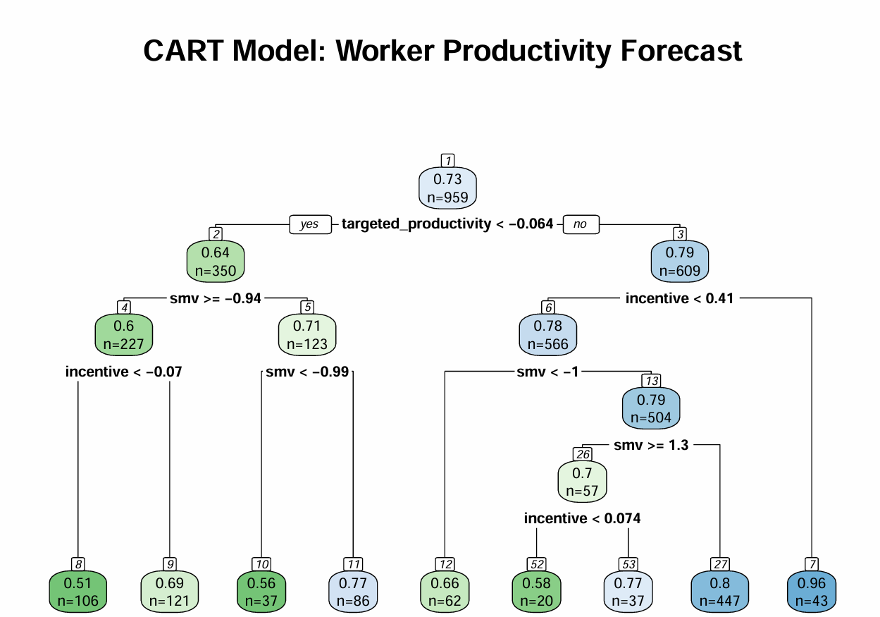

1. CART Model Accuracy
The model's performance metrics on the test set are:
- RMSE (Root Mean Squared Error): 0.1342
  - This is the average magnitude of the errors in the model's predictions. Compared to the NNET model (RMSE≈0.116) and GLMNET (RMSE≈0.131), the CART model has the highest error.
- R-squared (R2): 0.3576
  - The model explains only 35.76% of the variance in actual worker productivity. This is the lowest R2 of the models tested (NNET ≈0.515, GLMNET ≈0.374).
Conclusion on Accuracy: The single CART (Decision Tree) is too simplistic to capture the complex, non-linear relationships in the data. While it is the most interpretable model, its accuracy is insufficient compared to the penalized linear model (GLMNET) and the Neural Network (NNET).

2. Interpretation of the Decision Tree Structure
The visualization of the CART model shows the specific rules learned by the algorithm to predict productivity. The values in each node represent the average predicted productivity score and the number of observations (n) that fall into that node. (Note: The feature values are scaled).

Root Node (Node 1)
- Average Productivity: 0.73
- Total Observations: 959
- First Split: targeted_productivity<−0.064. This is the single most important factor determining the initial split in the data.

High Productivity Path (Right Side)
The path leading to the highest productivity is for teams who met or exceeded the targeted productivity (targeted_productivity≥−0.064):
- Path 1 (Best Performance): If incentive≥0.41, productivity is highest.
  - Node 7 (Leaf Node): 0.96 productivity, n=43 observations. This small group of teams receiving a very high incentive achieves near-perfect productivity.
- Path 2 (High Performance): If incentive<0.41 , and smv≥1.3 (Standard Minute Value is high):
  - Node 27 (Leaf Node): 0.80 productivity, n=447 observations. This is a large, high-performing group.

Low Productivity Path (Left Side)
The path leading to the lowest productivity is for teams who did not meet the targeted productivity (targeted_productivity<−0.064):
- Path 3 (Worst Performance): If smv≥−0.94 and incentive<−0.07 (low incentive):
  - Node 8 (Leaf Node): 0.51 productivity, n=106 observations. This group represents the worst-performing teams, characterized by low target achievement and very low incentive.

Key Drivers:
- Targeted Productivity: The primary split shows that achieving the target is the foundation for high productivity.
- Incentive: The highest productivity (0.96) is directly tied to a high incentive value (≥0.41).
- SMV (Standard Minute Value): This factor serves as a secondary split, often differentiating performance levels within the broader groups defined by target and incentive.

Clustering and PCA

print(summary(pca_obj))
Importance of components:
PC1 PC2 PC3 PC4 PC5 PC6 PC7 PC8 PC9
Standard deviation 2.1294 1.3200 1.2820 1.22767 1.16346 1.14934 1.13537 1.11787 1.10759
Proportion of Variance 0.1374 0.0528 0.0498 0.04567 0.04102 0.04003 0.03906 0.03787 0.03717
Cumulative Proportion 0.1374 0.1902 0.2400 0.28568 0.32670 0.36673 0.40579 0.44366 0.48083
PC10 PC11 PC12 PC13 PC14 PC15 PC16 PC17 PC18
Standard deviation 1.09769 1.08049 1.07258 1.05786 1.0514 1.04532 1.04302 1.03929 1.03693
Proportion of Variance 0.03651 0.03538 0.03486 0.03391 0.0335 0.03311 0.03297 0.03273 0.03258
Cumulative Proportion 0.51734 0.55272 0.58758 0.62149 0.6550 0.68810 0.72107 0.75380 0.78638
PC19 PC20 PC21 PC22 PC23 PC24 PC25 PC26 PC27
Standard deviation 1.02736 1.01860 1.00573 0.92717 0.90528 0.86906 0.83750 0.60776 0.5297
Proportion of Variance 0.03198 0.03144 0.03065 0.02605 0.02483 0.02289 0.02125 0.01119 0.0085
Cumulative Proportion 0.81836 0.84980 0.88046 0.90650 0.93134 0.95423 0.97548 0.98667 0.9952
PC28 PC29 PC30 PC31 PC32 PC33
Standard deviation 0.34895 0.19350 8.564e-15 2.961e-15 2.87e-15 1.914e-15
Proportion of Variance 0.00369 0.00113 0.000e+00 0.000e+00 0.00e+00 0.000e+00
Cumulative Proportion 0.99887 1.00000 1.000e+00 1.000e+00 1.00e+00 1.000e+00
>
> # Visualize PCA Scree Plot (Variance Explained)
> cat("\n[Image: PCA Scree Plot]\n")

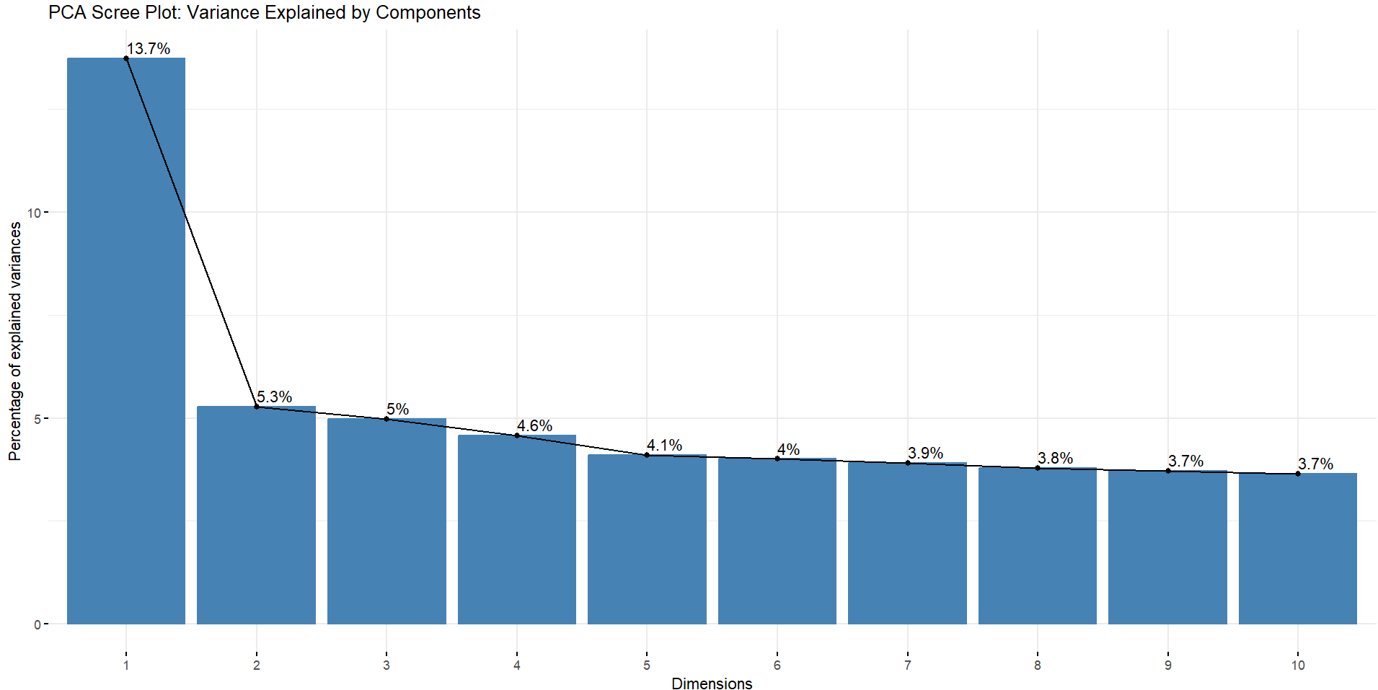
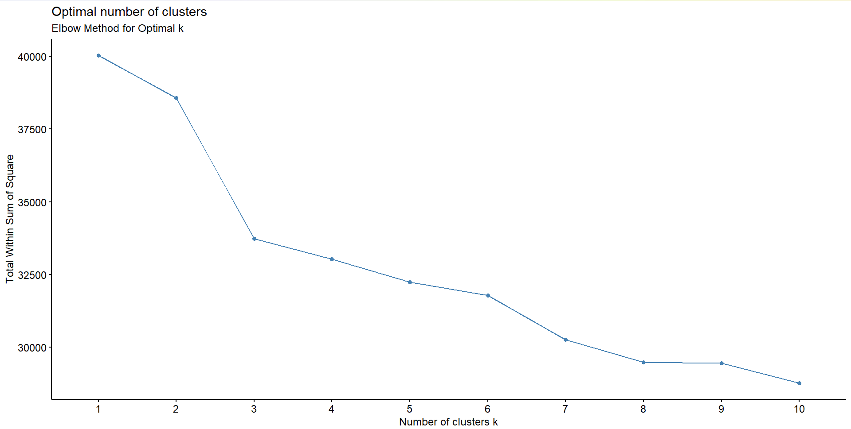
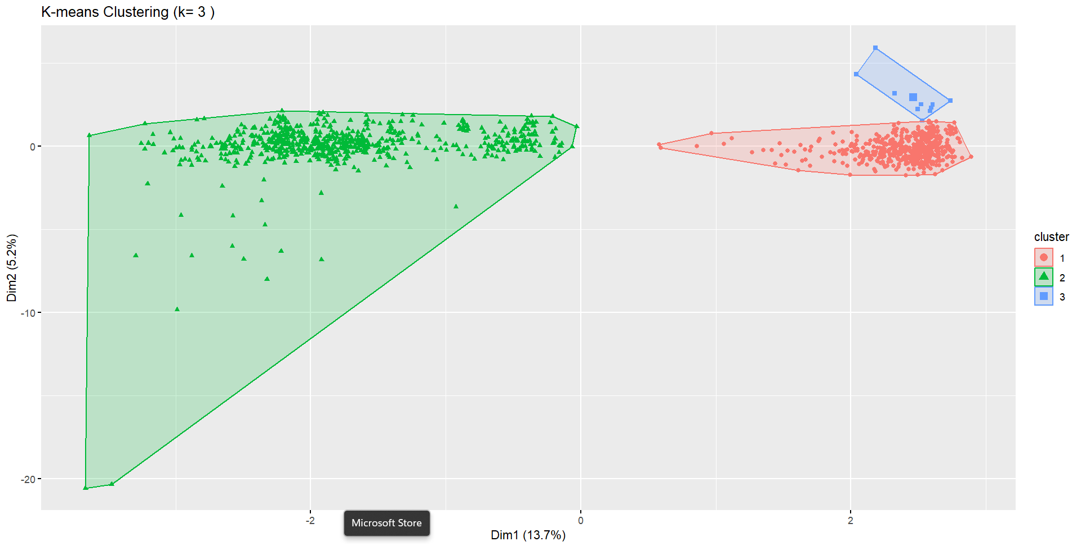
interpretation of the results and visualizations:

1. Principal Component Analysis (PCA)
PCA identifies a smaller set of uncorrelated components that capture the variance in the data.

PCA Scree Plot and Summary (image_4695e7.png)
Component | Proportion of Variance | Cumulative Proportion
PC1 | 13.74% | 13.74%
PC2 | 5.28% | 19.02%
PC3 | 4.98% | 24.00%
PC10 | 3.65% | 51.73%
PC18 | 3.26% | 78.64%
Export to Sheets
Key Insights:
- Low Initial Variance Explained: Unlike typical datasets, the first Principal Component (PC1) explains only 13.7% of the total variance. This is a relatively low concentration of variance and suggests that the data's complexity is not dominated by a single, powerful factor.
- High Dimensionality: To capture 80% of the total variance, you need to retain a large number of components (19 components are needed to reach 81.8% cumulative variance).
- Collinearity Confirmation: Since you had 33 original features, this high dimensionality confirms that while redundancy exists (evidenced by the high VIF scores), the variables' information is spread across many components. PCA would not be highly effective for severe dimensionality reduction here unless you accept a large loss of variance.

2. K-means Clustering (Exploratory)

Elbow Method for Optimal k (image_46994d.png)
The Elbow Method plots the Total Within Sum of Square (WSS), and the "elbow" where the reduction in WSS begins to flatten suggests the optimal number of clusters (k).
- Observation: There is a sharp drop from k=1 to k=2 and k=3. The curve starts to flatten noticeably after k=3 and k=4.
- Conclusion: k=3 or k=4 would be reasonable choices for the number of distinct productivity profiles within the dataset.

K-means Cluster Visualization (k=3) (image_4699a7.png)
The plot visualizes the three clusters by projecting the high-dimensional data onto the two largest principal components (PC1 and PC2).
- Cluster 2 (Green Triangles): This is the Largest Cluster. It represents the vast majority of observations (workers/days). It has a very wide spread across both Dim1 and Dim2, indicating this group is highly diverse in its underlying factors. This likely represents the "Average/Normal Operation" days, encompassing many different teams and departments.
- Cluster 1 (Red Circles): This cluster is highly concentrated in the positive Dim1 space (around x=1 to x=3) and around the center of Dim2. This represents a distinct, high-volume group, likely characterized by a specific combination of factors (e.g., high targeted_productivity and high incentive).
- Cluster 3 (Blue Squares): This is the Smallest Cluster. It is highly concentrated in the upper-right corner (high Dim1, high Dim2). This suggests a rare, extreme condition, possibly teams with very high-value inputs (e.g., specific combination of department and over_time) leading to a unique operational profile.
Overall Conclusion: The clustering successfully separates a large, normal population (Green) from two smaller, unique operational profiles (Red and Blue), indicating that a segmentation approach could be beneficial before predictive modeling.

